**CIS 229 – Python Programming – Programming Assignment**

**Guess My Number (No Loops)**

Overview

In this assignment, the student will write a Python script that deploys a number guessing game that requires the use of conditional logic and decision making control structures during its construction.

When completing this assignment, the student should demonstrate mastery of the following concepts:

* Functions
* Console Screen Clearing
* Boolean Logic
* Conditional Logic
* Intuitive Interface Design

Assignment

In this assignment, you will be writing a Python script that implements a number guessing game. The game will begin by asking a user to enter a secret number. In actuality, the player would have someone sitting next to them think of a number, enter it on the keyboard, and hit enter. After the secret number is accepted, the screen will clear and the player will be given 5 guesses to try and figure out the number. After each guess, the program will indicate whether the secret number is higher or lower than the guess. If the user guesses the secret number, a victory message is displayed and the script ends. If the user is unable to get the number within 5 guesses, the program displays a defeat message and the program also ends.

In this assignment, you must make use of the knowledge learned in the class up to this point only. You cannot do any looping or use any control structures that have not been discussed in class. The one exception to this rule is the technique used to clear the screen after the number creator enters the secret number. The following function can be used to clear the Python interpreter view.

def ClearScreen():

 clear = '\n' * 100

 print(clear)

It is recommended that you write functions to assist in commonly repeated tasks. Use global variables to communicate information that needs to be returned from functions and use argument passing to convey information that needs to be passed into functions. Your program will have a somewhat repetitious look when complete since looping structures are not allowed, but this is understandable and expected. Use the following example runs as a reference point and model your program’s output after them:

Example Scenario #1 – Victory

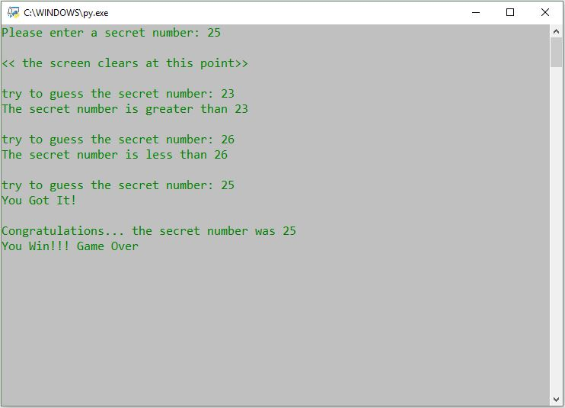

Example Scenario #1 –Defeat

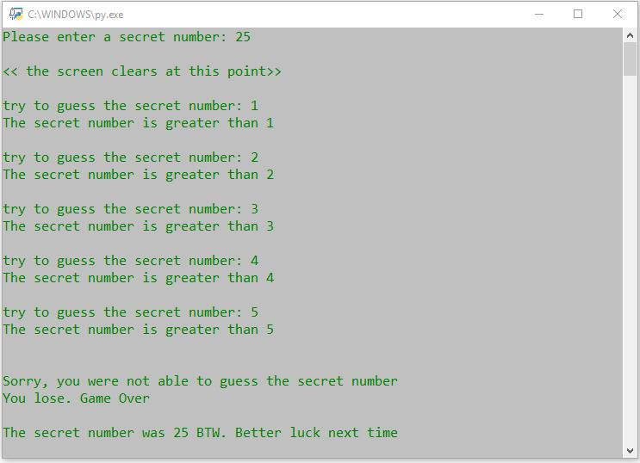

Assessment

This assignment will be assessed based on the provided grading rubric.